SCIENCE
PERFORMANCE TASK

NAME: ____________________________ GRADE 5 DATE: _____________

HOW FAST IS MY CAR?
General Instructions:
This task has two parts: part one has 5 questions and part two has 4 questions.
Source 1
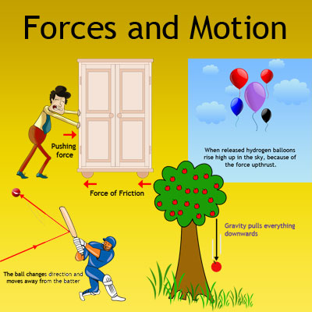
Source 2
Motion makes the world go 'round. Motion makes the moon go 'round too. In fact, motion makes lots of things go. When we think of motion we often think of cars, bicycles, kids running, basketballs bouncing and airplanes flying. But motion is so much more. Motion is important to our lives and impacts so many things that we do. Motion is the changing of position or location. But motion requires a force to cause that change.
Force is just a fancy word for pushing or pulling. If I push on something or pull on it, then I am applying a force to it. Force makes things move or, more accurately, makes things change their motion. Two natural forces that we have experienced are the force of gravity and magnetic forces. These two forces act at a distance and do not require direct contact between the objects to function. Gravity produces a force that pulls objects towards each other, like a person towards the ground. It is the force that keeps the Earth revolving around the sun and it's what pulls you toward the ground when you trip.
Source 3
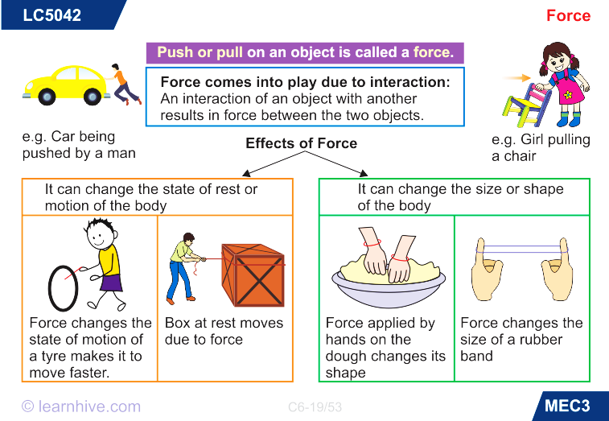
Part 1
Jaylen enjoyed playing with his toy cars. He loved to make them go fast, but he wanted to find out if he could get the cars to go even faster and farther, so he decided to do a science project. Jaylen constructed ramps for his toy cars out of everyday items with the help of his parents. Then he did a few tests to find out which ramp would be better for his cars to reach the bottom of each ramp the fastest and which would go the longest distance. You are asked to help Jaylen answer a few questions about his investigation and write a scientific report about his experiment.
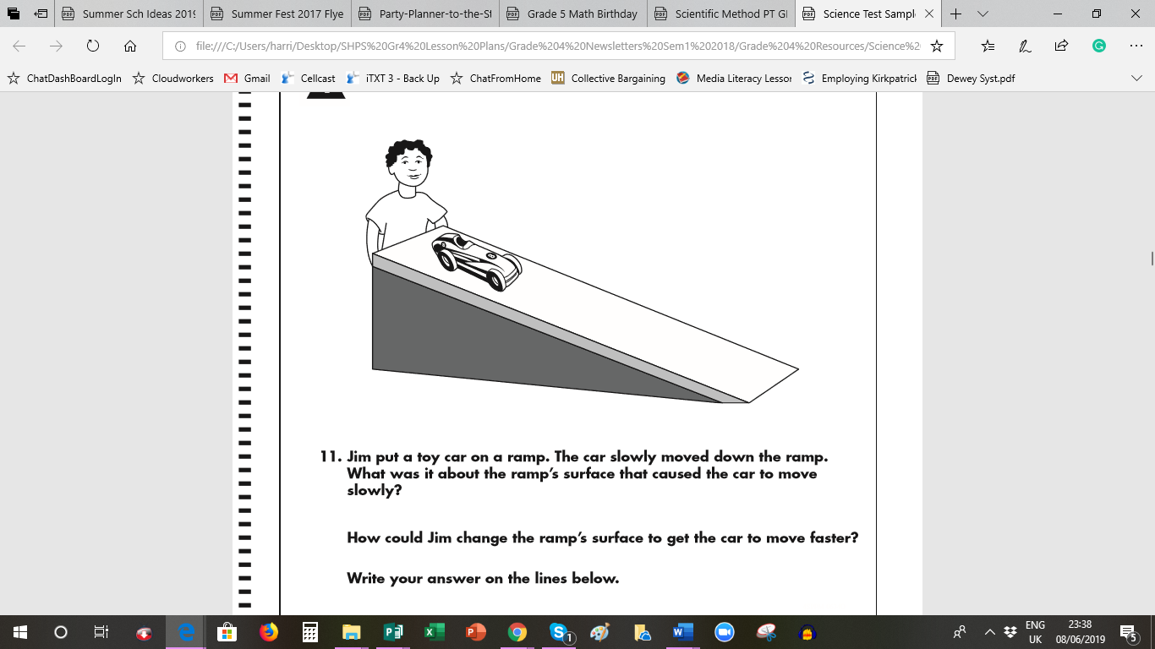

- Jaylen placed a toy car on a lined ramp. The car slowly moved down the ramp. Do you think the surface of the ramp could have affected the speed at which the car went? Explain by citing which source supports this phenomenon.
________________________________________________________________________________________________________________________________________________________________________________________________________________________________________________________________________________________________________________________________________________________________________1 b. Which force was at work in this case? _____________________________________________________
_________________________________________________________________________________________
- During the investigation, Jaylen decided to move the toy car down another ramp. He did three trials and wrote the data on a piece of paper. Why was it necessary to conduct three trials? Determine what caused the car to move down the ramp.
______________________________________________________________________________________________________________________________________________________________________________________________________________________________________________________________________________
- The distance the toy car travelled is shown below. The starting and ending points are represented by a dot. About how far past the end of the ramp did the car travel?
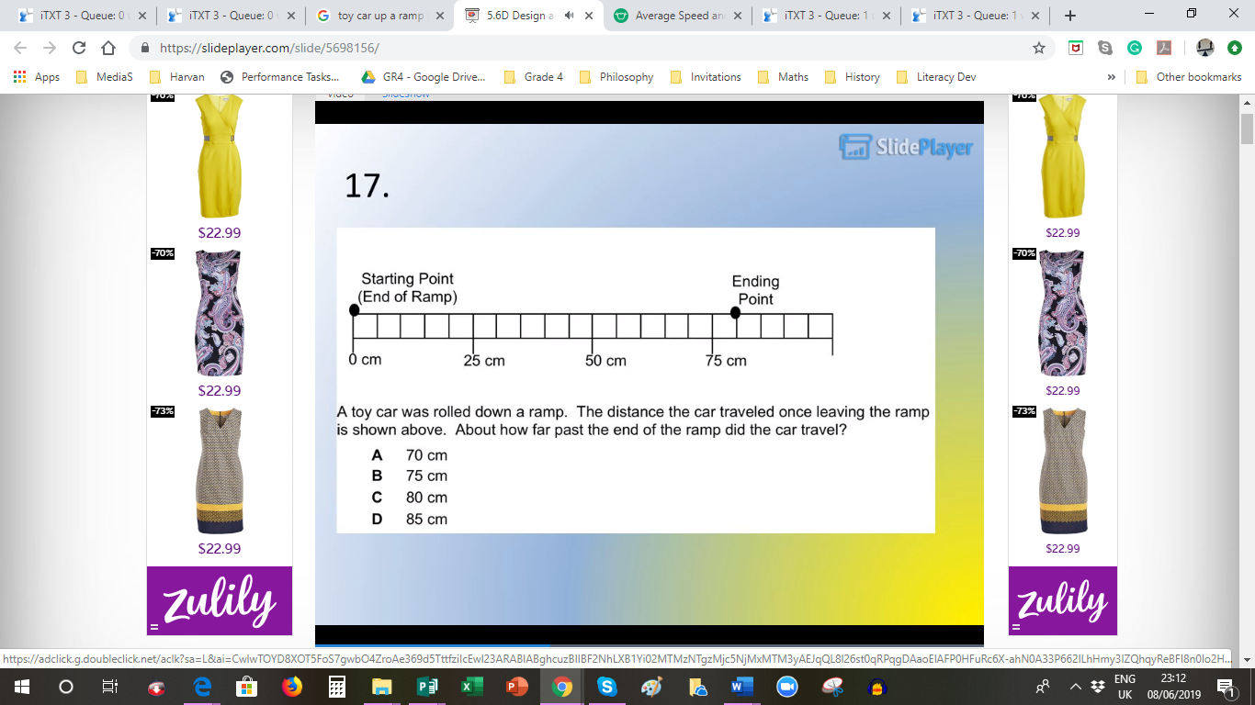

(END OF RAMP)
___________________________________
- Suggest 2 factors that could affect how fast or slow the car travelled? Use information from the sources to support your reasoning. ____________________________________________________________________________________________________________________________________________________________________________________________________________________________________________________________________________________________________________________________________________________________

Part 2
- Jaylen was not satisfied with the speed of his car going down the ramp, so he decided to conduct a few more experiments. He wanted to find out if the height of the ramp affected the speed of his toy car once rolled down it. His father decided to shop for pieces of board to help construct the two ramps. Write to explain which picture illustrates his father using the most force. Justify your answer using information from the sources.
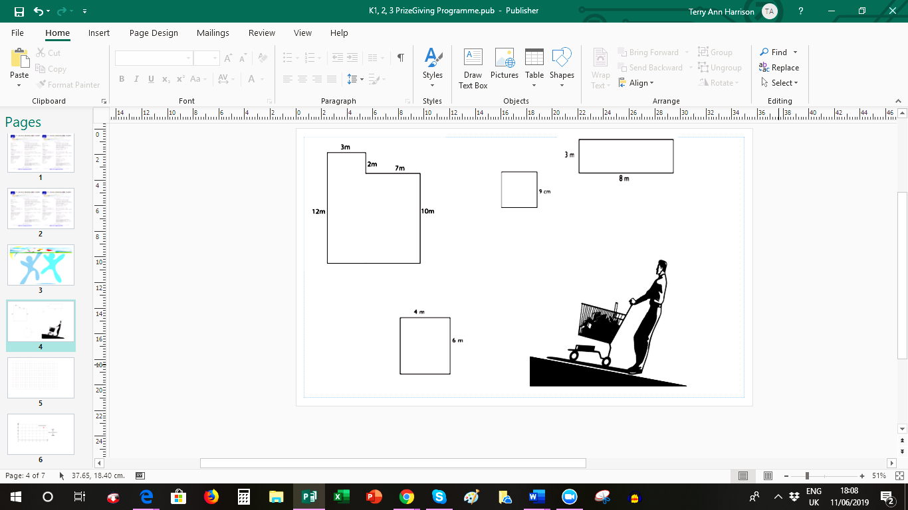

______________________________________________________________________________________________________________________________________________________________________________________________________________________________________________________________________________
__________________________________________________________________________________________
- As soon as his father got home, they constructed the ramps. He chose his best toy cars and set up the two ramps as shown in the image below. He started with a low ramp then raised the top end of the second ramp. Write a reasonable hypothesis for Jaylen’s experiment.
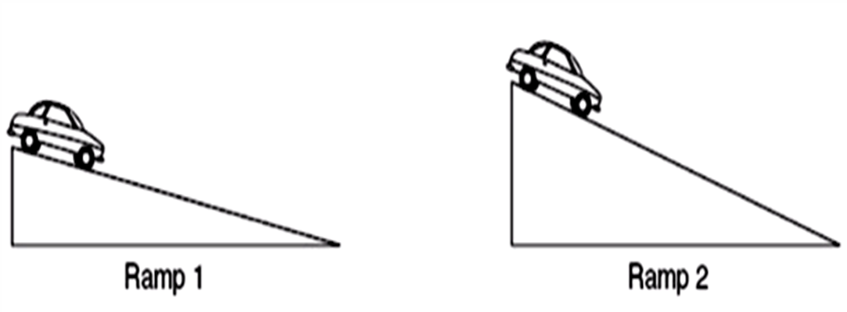
____________________________________________________________________________________________________________________________________________________________________________________

- Do you believe that the angle of the ramp would affect the speed and distance the toy cars travel? Explain your reasoning.
______________________________________________________________________________________________________________________________________________________________________________________________________________________________________________________________________________
__________________________________________________________________________________________
__________________________________________________________________________________________
- Jaylen wanted to share how much fun he had testing the speed of the cars with his friends, but he forgot to write a scientific report about his investigation. Design a report using the lab sheet included in this Performance Task to reflect what Jaylen should include so that others can replicate his experiment.

LAB REPORT TEMPLATE

Title:
- A brief concise, yet descriptive title

Statement of the Problem:
- What question(s) are you trying to answer?
- Include any preliminary observations or background information about the subject

Hypothesis
- Write a possible solution for the problem
- Make sure this possible solution is a complete sentence
- Make sure the statement is testable
- The statement should reference the independent and dependent variables: such as “The plant group receiving (independent variable i.e. fertilizer) will (dependent variable i.e. produce more fruit) than the plants that did not receive (independent variable i.e. fertilizer)

Materials:
- Make a list of all items used in the lab

Procedure:
- Write a paragraph or a list which explains what you did in the lab.
- Your procedure should be written so than anyone else could repeat the experiment.

Results:
- This section should include any data tables, observations, or additional notes you make during the lab.
- Although some students may wish to recopy original data: it is important to always preserve the orginal
- You may attach a separate sheet(s) if necessary.
- All tables, graphs and charts should be labeled appropriately.

Conclusions:
- Accept or reject your hypothesis
- EXPLAIN why you accepted or rejected your hypothesis using data from the lab.
- Include a summary of the data – averages, highest, lowest, etc. to help the reader understand your results.
- List one thing you learned and describe how it applies to a real-life situation.
- discuss possible errors that could have occurred in the collection of data (experimental errors)

LAB REPORT FORM

(Name) ____________________________ (Date) _______________

Title:

Purpose/Problem

Hypothesis:

Materials/Supplies:

Procedure:

Observations and Data:

Conclusion/Summary:
Conclusion Do’s and Don’ts
- Do draw an illustration or a graph, if appropriate.
- Don’t list the data again, but summarize, discuss, and analyze the data.
- Do explain why your hypothesis was correct or incorrect from your observations or data.
- Don’t give the procedure again, but do point out possible sources of error.
- Don’t forget to break up your ideas with more than one paragraph. Your conclusion is an essay.

Helpful format for writing a conclusion
(length of blank lines does NOT indicate the length of your entries – additional sentences are encouraged)
This lab (experiment) investigated _______________________________.
In order to study the problem we ________________________________.
My results showed _________________________________, thus proving my hypothesis was (correct/incorrect).
I believe the results are (accurate/inaccurate) because ________________.
In order to further investigate this problem, next time I would __________.

The above was adapted from Cheryl Randall’s Science Lab Report found at http: donnayoung.org/apologia/lab/labhow~cr.htm

