SOCIAL STUDIES
PERFORMANCE TASK

NAME: ____________________________ GRADE 5 DATE: _____________

General Instructions:
This task has two parts: part one has 4 tasks, part two has 8 statements and part 3 has 1 task.
Task: Any day of the school year is a wonderful day for a special event, but it is often said that the during the school year, “Culture Day” is a perfect time to celebrate. As the Student Advisor, you are asked to assist the Student President in planning the Culture Day for your school. You are tasked with creating an action plan giving a clear outline of what will be included throughout the day.
Part 1
The Fidelitas School is having a Cultural Day focussing on the contribution of the different ethnic groups to the Jamaican Society. Read the sources, make notes where possible and use the information to assist you in answering the questions that follow.

Source 1
Cultural Heritage the Focus for Jamaica Day – Jamaica Gleaner
Schools across the island joined in the national observation of Jamaica Day on Friday, February 24, under the theme: ‘Celebrating Jamaica: Exploring Our Legacy”. Senior Education Officer in the Ministry of Education, Youth and Information, Marlon Williams, who launched Jamaica Day at a recent ceremony at the Herbert Morrison Technical High School in Montego Bay, St. James, said the mission of the day’s observation is to encourage an appreciation for the nation’s cultural heritage, especially among students.

“Jamaica Day is an annual event designed to contribute to citizenship education and to enhance the appreciation for Jamaica’s rich heritage and culture which builds positive identity in our students and, by extension, our nation,” he explained. Mr. Williams said students and teachers as well as members of the society are expected to wear the national colours on that day, while schools are expected to be decorated accordingly. “We are expecting that the Jamaican colours will be worn by everyone in all entities and sectors on that day as a symbol of our commitment to celebrating the many legacies that have made and are making Jamaica one of the greatest nations on earth,” he said. Mr. Williams is also encouraging schools to research their history and on Jamaica Day they should focus the observation on their own legacies.

Jamaica Day, which is part of the Culture in Education Programme, was instituted in the nation’s schools by the Ministry of Education to celebrate what is called ‘Jamaicanness’ and the country’s contribution to the world.

Source 2
Fun Day, Nay Day!
From the Diary of a Student Leader.
A Fun Day can be many things. It is not just a day for us children to play with no other recourse. You must consider why you are doing it? How to plan for it? How to communicate to the students, school staff, and community? How to execute the day?
For me, it was all about what I wanted my friends and I to remember when we think back on Fun Day a decade from now. I had to think, how do I want the day and the process of planning it to improve our lives and the community in which we live?
Reflecting on last year’s Fun Day events always made me sweat. What do I remember? I remembered how much fun I had, the games I played, and spending time with my classmates. The Fun Day was a great chance for us as students to let loose, get active, and have a good time. And at the end of the day, it was all about creating a memorable experience.
The day wasn’t all fun and games. There was a whole lot of behind the scenes work done before the big day. This is what I called, the planning process for Fun Day. I had to ask myself a whole lot of questions before I put my pen to paper. Should I ask my teachers for help? Should I get booths, tents and more? Should I reach out to the school community to ask for donations? I even thought about just throwing some activities on a sheet of paper and drawing a map with a schedule. Do I need to alert the parents that children will get wet if I have water activities so there are no surprises when they come home with dirty clothes? Or should I assume that they will know being that it’s a fun day. Take nothing for granted when planning an event!
It was often said that the roadmap to a successful Fun Day comes through four main components: proper planning, communicating, execution, and follow-up. The level of planning done, and the amount of detail and communication placed into planning the Fun Day last year had a direct correlation between the kind of memories that I wanted all my friends to have decades from our primary school years. This could not have been done in a vacuum or over a couple days of throwing things together. It involved considering all the possible aspects a Fun Day will entail and working through each at a steady pace over a few months. As a backup plan, I followed these steps:
- Plan the Activities
- Formulate a Budget
- Recruit Volunteers
- Create a Rainy-Day Plan
- Prep for Fun Day (the Day Before)
- Setup Fun Day
The biggest challenges encountered during the planning stages of the fun day was identifying the ideal venue then establishing a budget and financial goals. Even though it was a school fun day, I had to consider the gym, cafeteria and playground as likely options that cost little to nothing to use. I also had to ensure that the location was safe, and able to accommodate the rides and activities that I had planned. Verifying if there was enough access to power sources, food facilities, bathrooms and parking was another issue. Thanks to careful planning, it was a Fun Day to remember!
Source 3
The Jamaican Culture
Symbolic of our heritage and history, 'Jamaica culture', as I shall call it, was fashioned around the mixture and influences of our many peoples. Our motto "Out of Many one People" perhaps provide the perfect definition and insight into our culture. We boast a rich blend of African, European, Chinese, Indian and some middle eastern cultures. Of course, the early Taino settlers played a pivotal role in our culture as well.

Different Ways We Celebrate being a Jamaican!
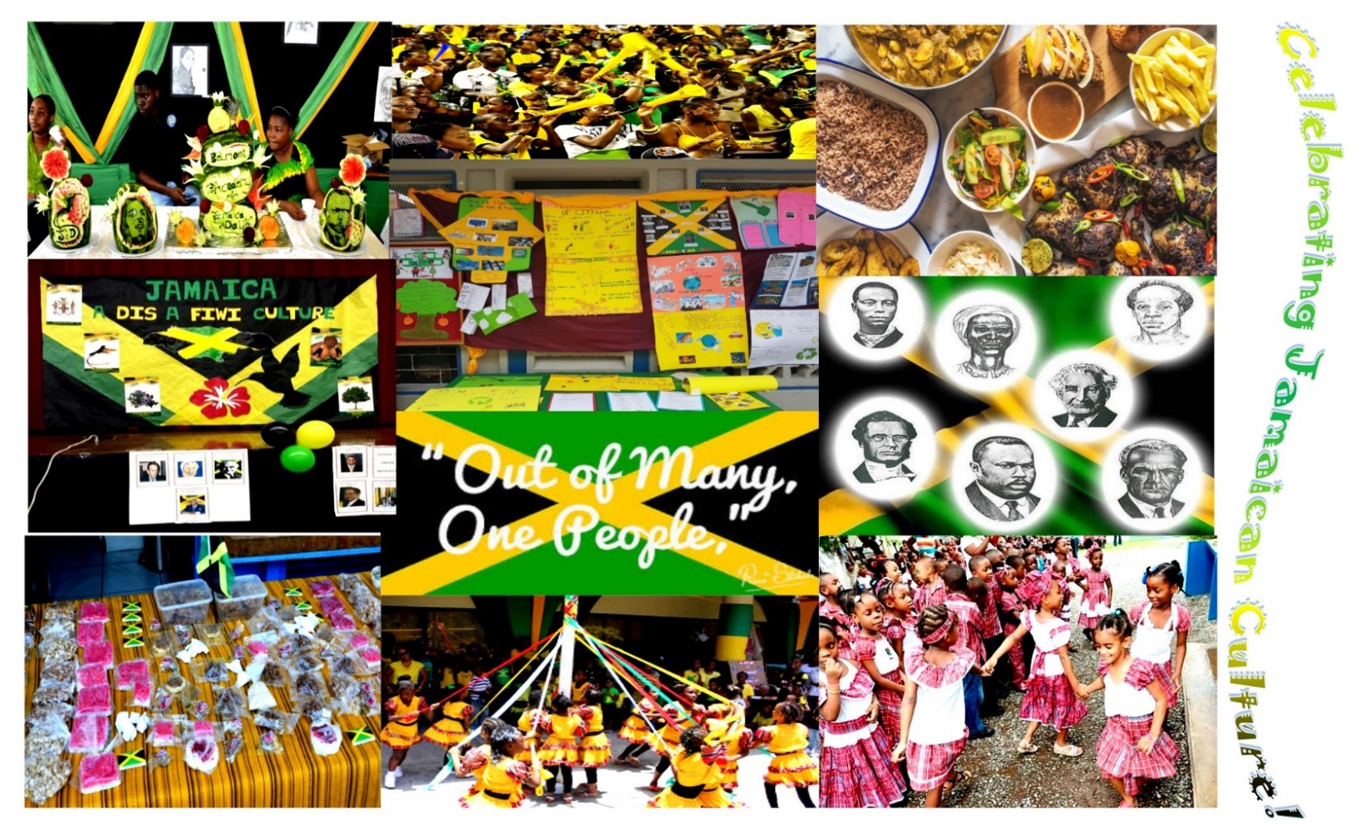

Part 1
Questions
- According to source 1, what would be the best advice to give to the Student President about preparing for the Culture Day? Include at least four appropriate suggestions from source one that would be useful for the Student Present.
____________________________________________________________________________________________________________________________________________________________________________________________________________________________________________________________________________________________________________________________________________________________________________________________________________________________________________________________________________________________________________________________________________________________
- Putting on a fun day can be a popular, enjoyable way to raise funds for your school, but it requires a lot of work to be successful. What are the pros and cons of planning ahead and preparing a budget? Justify your answer using information garnered from the sources.
____________________________________________________________________________________________________________________________________________________________________________________________________________________________________________________________________________________________________________________________________________________________________________________________________________________________________________________________________________________________________________________________________________________________
- Identify two ways that Jamaicans celebrate their culture. Provide one detail from Source 1 and one detail from Source 3 to support your answer. Be sure to identify the source of each piece of information by title or number.
____________________________________________________________________________________________________________________________________________________________________________________________________________________________________________________________________________________________________________________________________________________________________________________________________________________________________________________________________________________________________________________________________________________________
- Create a mini-poster or flyer advertising your event be sure to mention exciting things to persuade people to come.

Part 2
For each of the following statements, indicate using a tick whether the information in source 1, source 2, both sources, and neither source support each statement (you can tick only one box for each statement).

Statement | Source 1 | Source 2 | Both | Neither
- The venue plays a key part in planning for an event.
- Wearing special clothing helps to communicate the type of event.
- Once an event is properly organised, it takes little or no time to plan it.
- You should always have a backup plan to sure that your event will go well.
- Communication plays a key part in planning.
- You can use a Culture Day to remind and educate the public of years gone by.
- Jamaica Day is a biannual event.
- Planning an event should involve everyone effort to make it a success.

- Create a program with at least 5 items that can be performed at the Culture Day.

Part 3
- Using information from the sources, create a timetable of suggested activities for Fun Day to celebrate Jamaica Day at your school. Your plan should include different ways for the students to explore and learn about Jamaican culture which would fit within the regular hours of the school day 8a.m. to 1:45p.m.

TIME | ACTIVITY
8:00 – 9:00 a.m.

9:00 – 10:00 a.m.

10:00 – 10:30 a.m.

10:30 – 11:30 a.m.

11:30 – 12:30 p.m.

12:30 – 1:45p.m.

- Write a letter to your friend inviting him or her to your school to attend the event. Be sure to give details of the event, the type of performances as well as a detailed description of the food that will be on sale. Give your friend three good reasons why event will be beneficial to him/her.

____________________________________________________________________________________________________________________________________________________________________________________________________________________________________________________________________________________________________________________________________________________________________________________________________________________________________________________________________________________________________________________________________________________________
________________________________________________________________________________________________________________________________________________________________________________________________________________________________________________________________________________________________________________________________________________________________________________________________________________________________________________________________________________________________________________________________________________________________________________________________________________________________________________________________________________________________________________________________________________________________________________________________________________________________________________________________________________________________________________________________________________________________________________________________________________________________________________________________________________________________________________________________________________________________________________________________________________________________________________________________________________________________________________________________________________________________________________________________________________________________________________________________________________________________________________________________________________________________________________________________________________________________________________________________________________________________________________________________________________________________________________________________________________________________________________________________________________________________________________________________________________________________________________________________________________________________________________________________________________________________________________________________________________________________________________________________________________________________________________________________________________________________________________________________________________________________________________________________________________________________________________________________________________________________________________________________________________________________________________________________________________________

